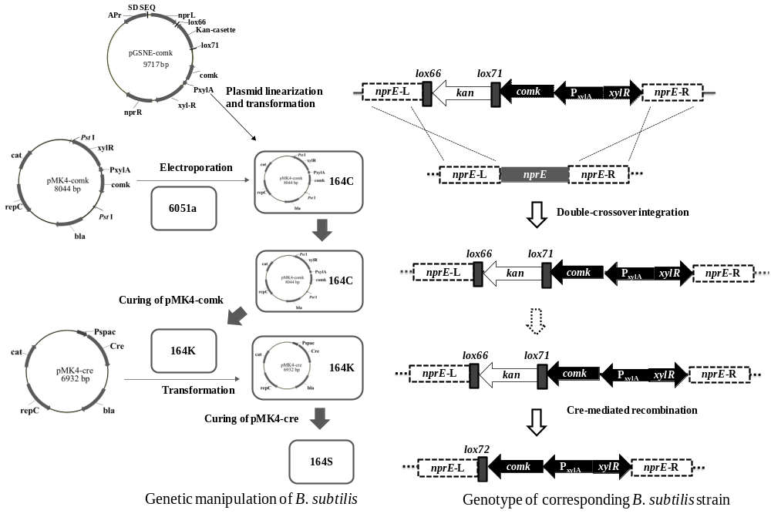

Fig. S1 Detailed diagram of engineering B. subtilis ATCC 6051a to B. subtilis 164S.

